**Data Collection and Preprocessing Phase**

|  |  |
| --- | --- |
| Date | 6 October 2025 |
| Team ID | xxxxxx |
| Project Title | Predicting Plant Growth Stages with Environmental and Management Data Using Power BI |
| Maximum Marks | 2 Marks |

**Data Collection Plan & Raw Data Sources Identification Template**

Elevate your data strategy with the Data Collection plan and the Raw Data Sources report, ensuring meticulous data curation and integrity for informed decision-making in every analysis and decision-making endeavor.

**Raw Data Sources Identification Report**

**1. Project and Source Overview**

|  |  |
| --- | --- |
| **Element** | **Detail** |
| Project Name | Predicting Plant Growth Stages with Environmental and Management Data Using Power BI |
| Project Phase | Data Collection and Preprocessing Phase (Section 3) |

2. Primary Data Source Identification

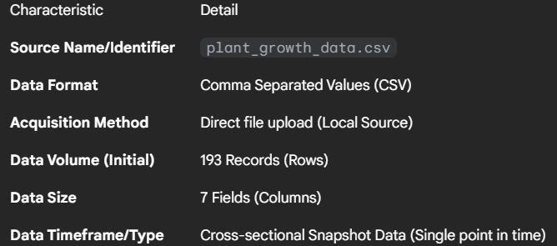

**3. Data Field (Column) Description**

The raw data contains seven fields necessary for analyzing the relationship between care factors and growth outcomes.

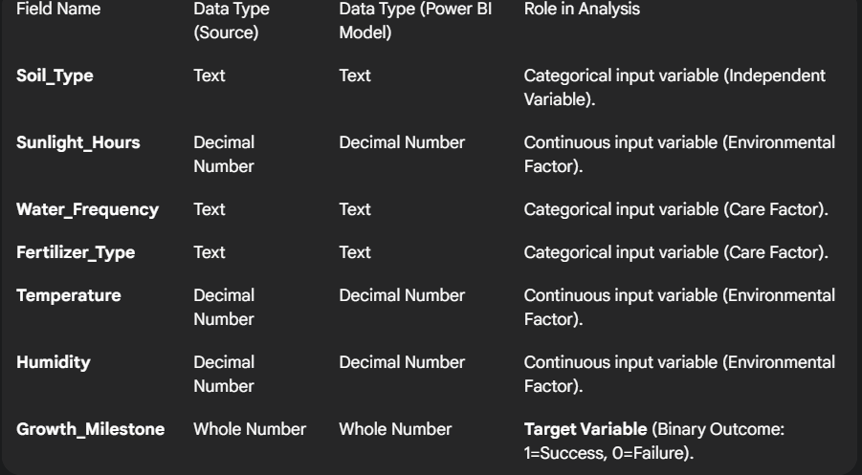

**4. Data Readiness and Collection Conclusion**

* **Data Completeness:** The source is **complete**, with zero missing values detected across all fields, simplifying the data preparation phase.
* **Data Consistency:** All categorical fields showed **uniformity** (e.g., consistent spelling and capitalization), requiring no standardization efforts.
* **Collection Conclusion:** The single CSV file serves as the definitive raw data source for the project. No further data collection is required. The next step is to proceed directly to the **Data Quality Report** and **Preprocessing** phase to create calculated columns and measures.